**Healthcare Data Analysis Report**

**Prepared by:** Roshan Nikam

**Executive Summary**

This report provides a detailed visual analysis of a healthcare dataset using Power BI. The dataset contains patient records with details such as demographics, medical conditions, hospital admission details, billing information, and test results.

The analysis highlights key insights into patient demographics, common medical conditions, financial patterns across insurance providers, hospital resource usage, and clinical outcomes. These insights aim to support data-driven decisions for improving patient care and operational efficiency.

**📊 1. Demographic Analysis**

**Age Distribution**

* The majority of patients fall within in age of 60-90 and 18-40 the age group.
* Age group of 0-18 patients is low

**Gender Breakdown**

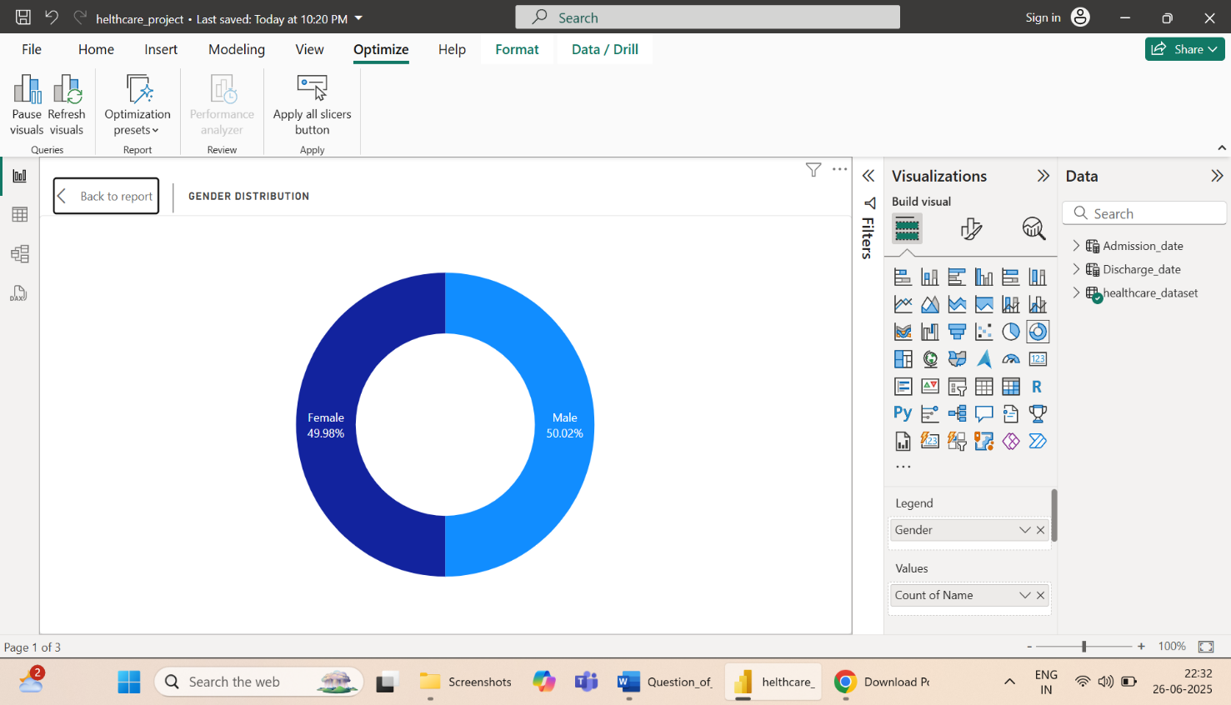

* Male: 50%, Female: 49.98%
* **Gender Brekdown of age group**

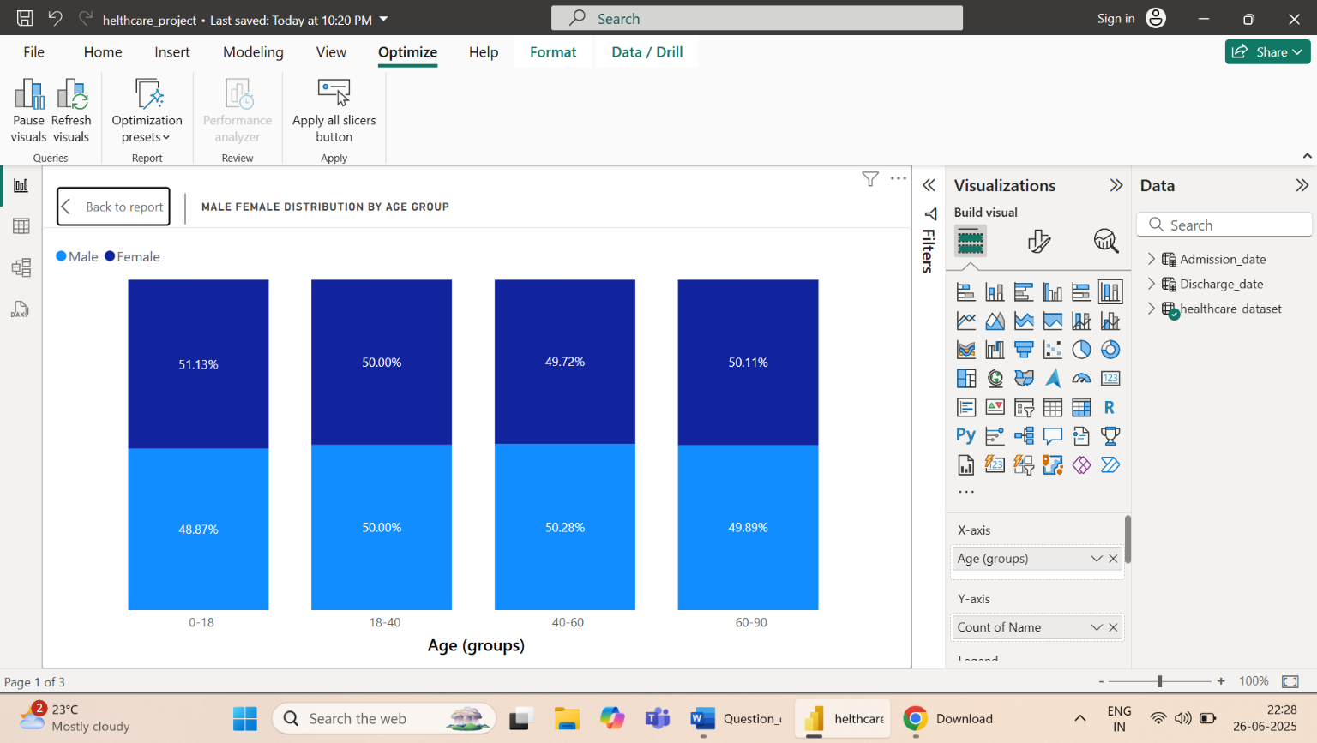

* **Blood Type Frequency**
* The most common blood types are [O+, A+, A-, B+, B-, AB+, AB-].
* The rare blood group type is [O-]

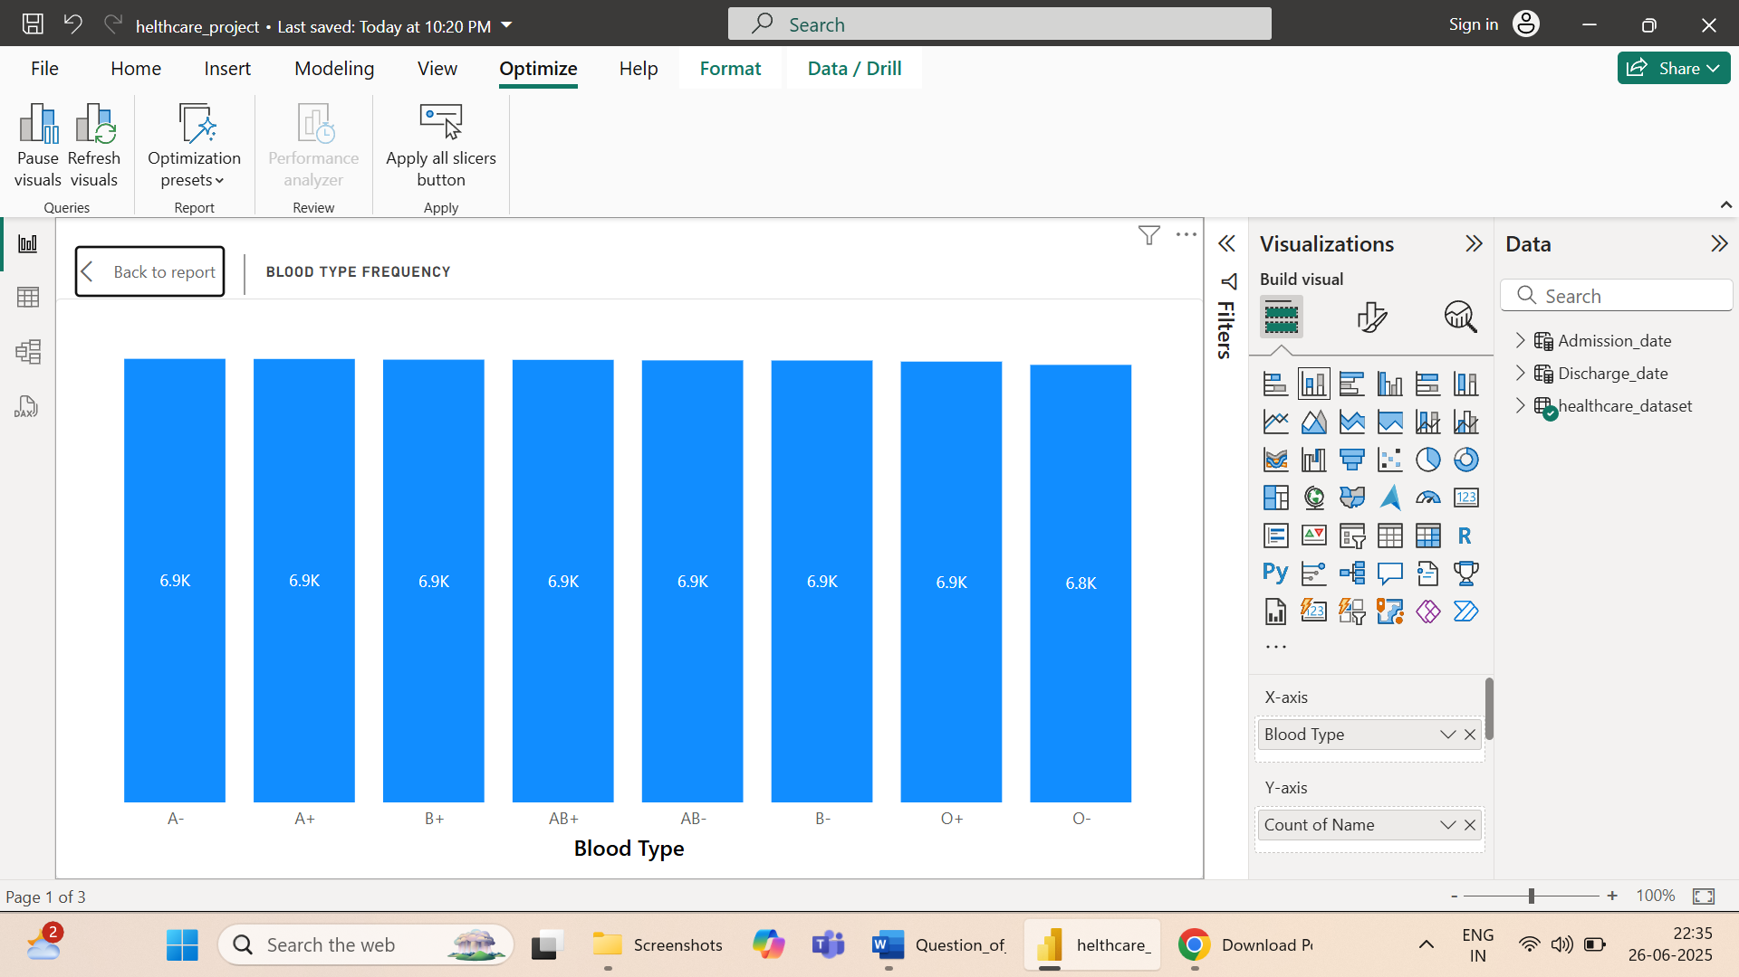

**🏥 2. Hospital Admission Trends**

**Admissions Over Time**

* Admission peaks are observed in eight months potentially linked to seasonal illnesses.

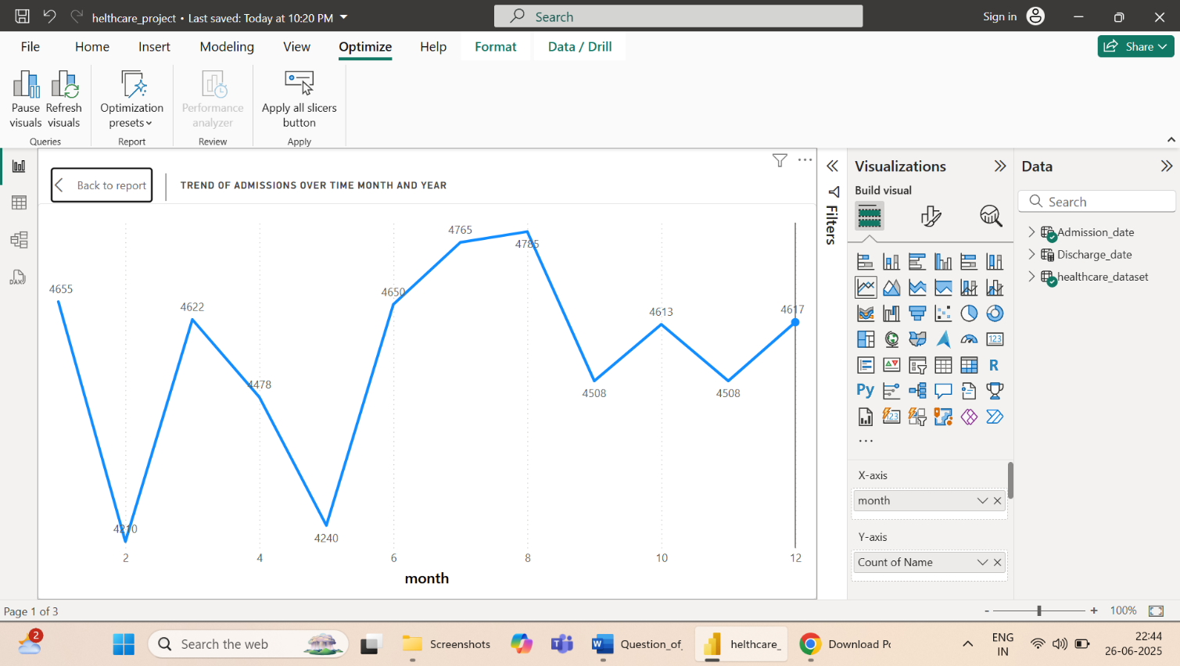

**Top Hospitals and Doctors**

* Hospital LLC Smith has the highest number of admissions.
* Each Dr. treated the one patient.

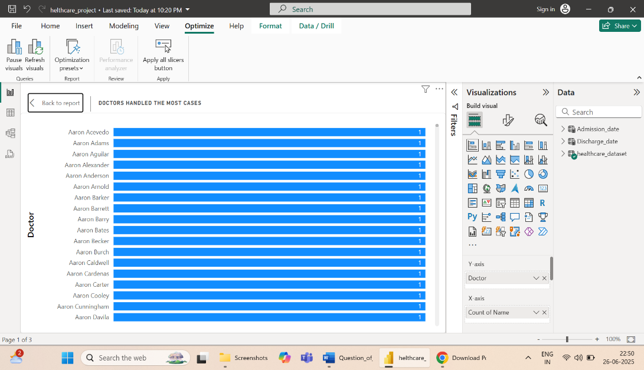

**Admission Types**

* The most frequent type is Elective followed by Emergency.

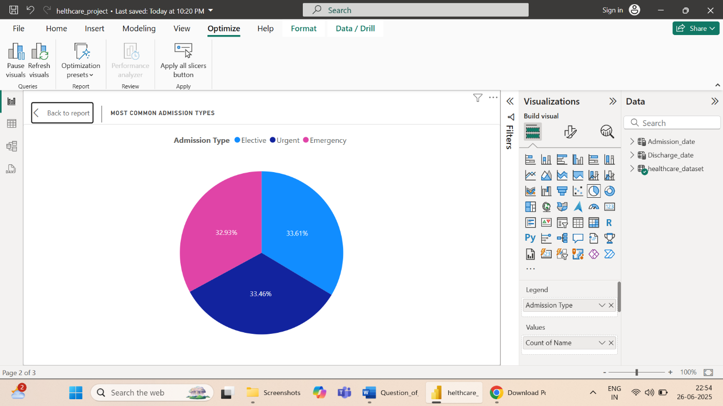

**💰 3. Billing & Insurance**

**Average Billing Amount by Insurance Provider**

* Highest average billing is associated with Medicare and Blue Cross

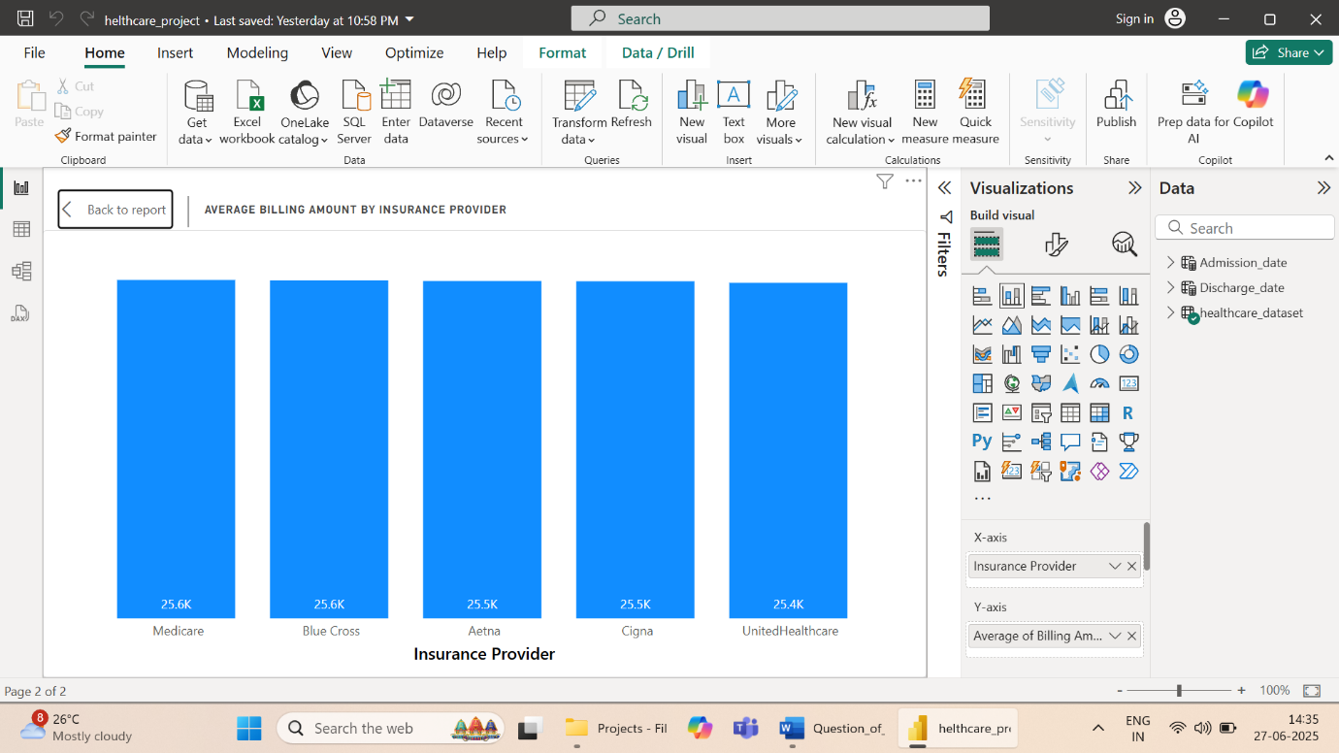

**Billing vs Room Number**

* Private rooms correlate with higher billing amounts.
* 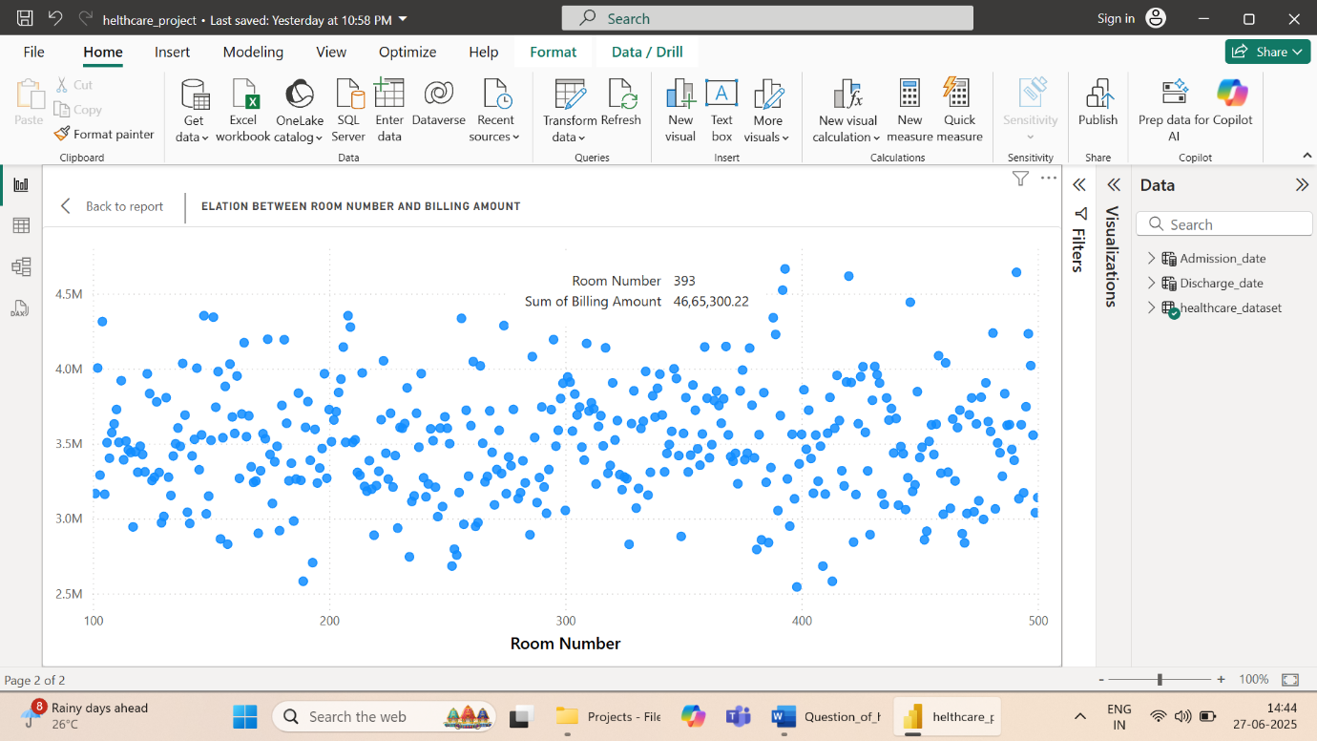

**Insurance Provider Usage**

* Most patients are covered by Cigna and Medicare.

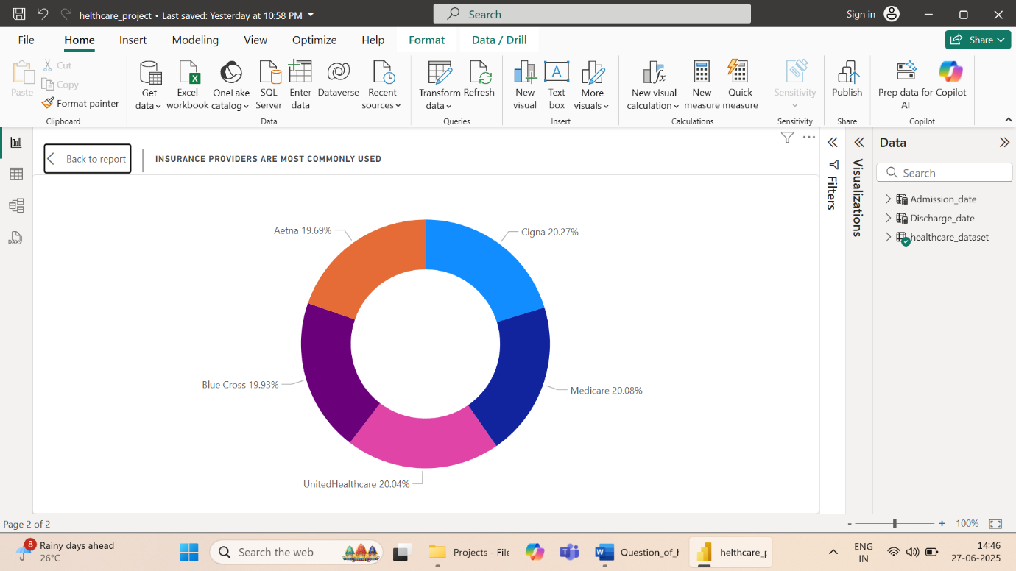

**💊 4. Medical Conditions & Treatments**

**Top Medical Conditions**

* Common diagnoses include Arthritis, Diabetes, Hypertension

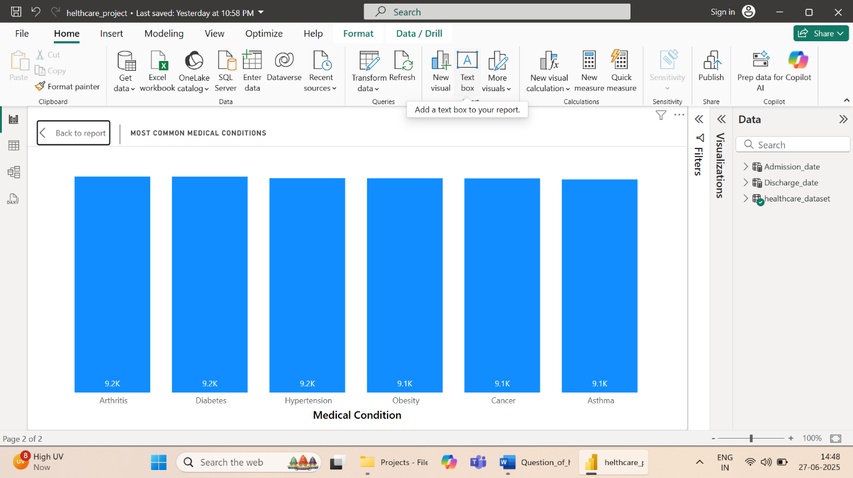

**Most Prescribed Medications**

* 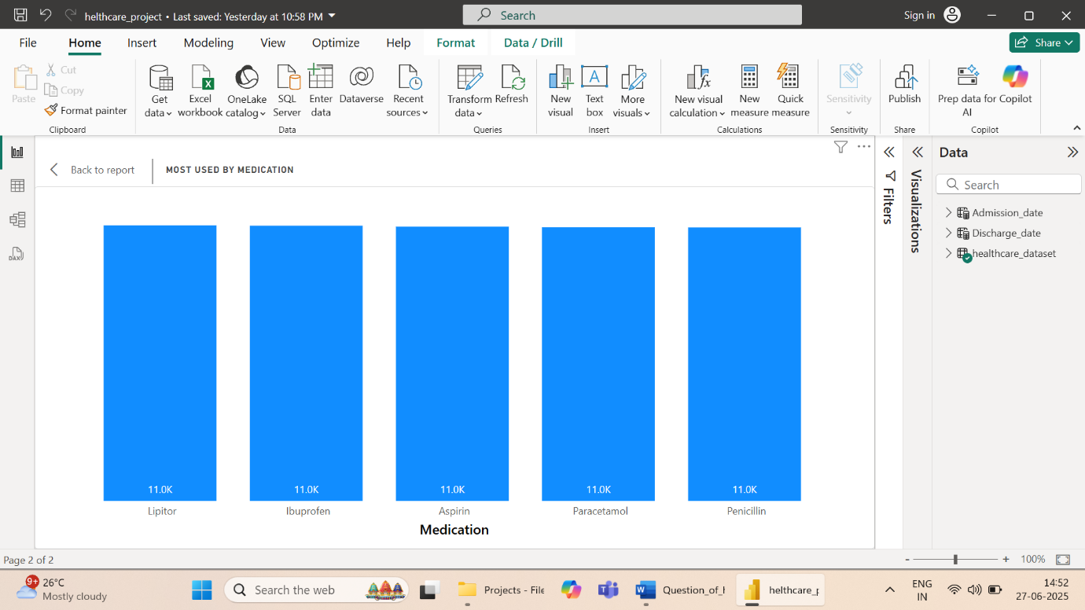Frequently prescribed medications include Lipitor but more difference to others

**Length of Stay by Condition**

* Longest average stays are seen in patients with Arthritis

**🔬 5. Test Results & Clinical Insights**

**Test Results Distribution**

* Most test results

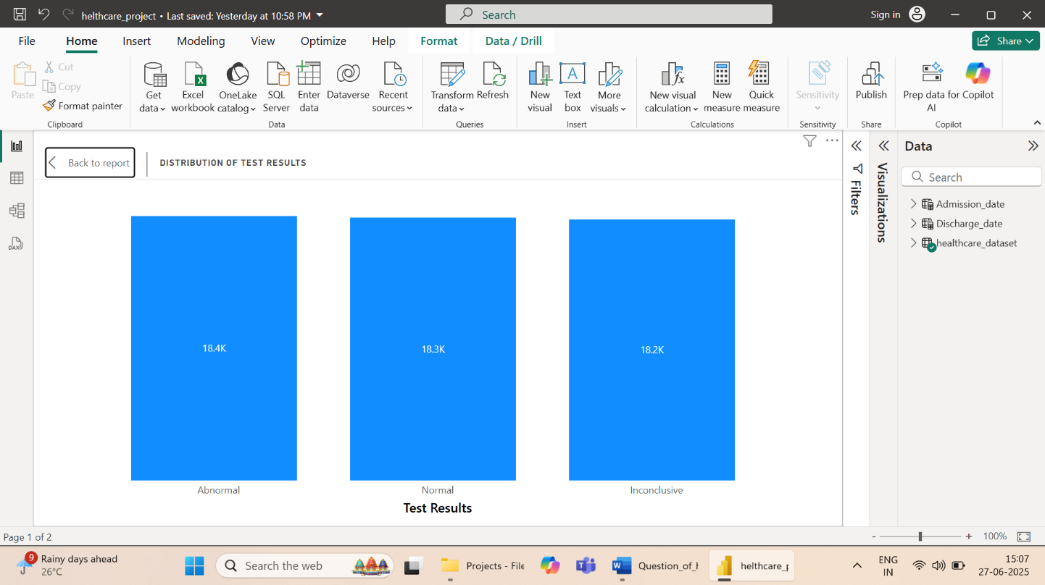

**Test Results vs Billing**

* A slight positive correlation was observed between test result levels and billing.
* 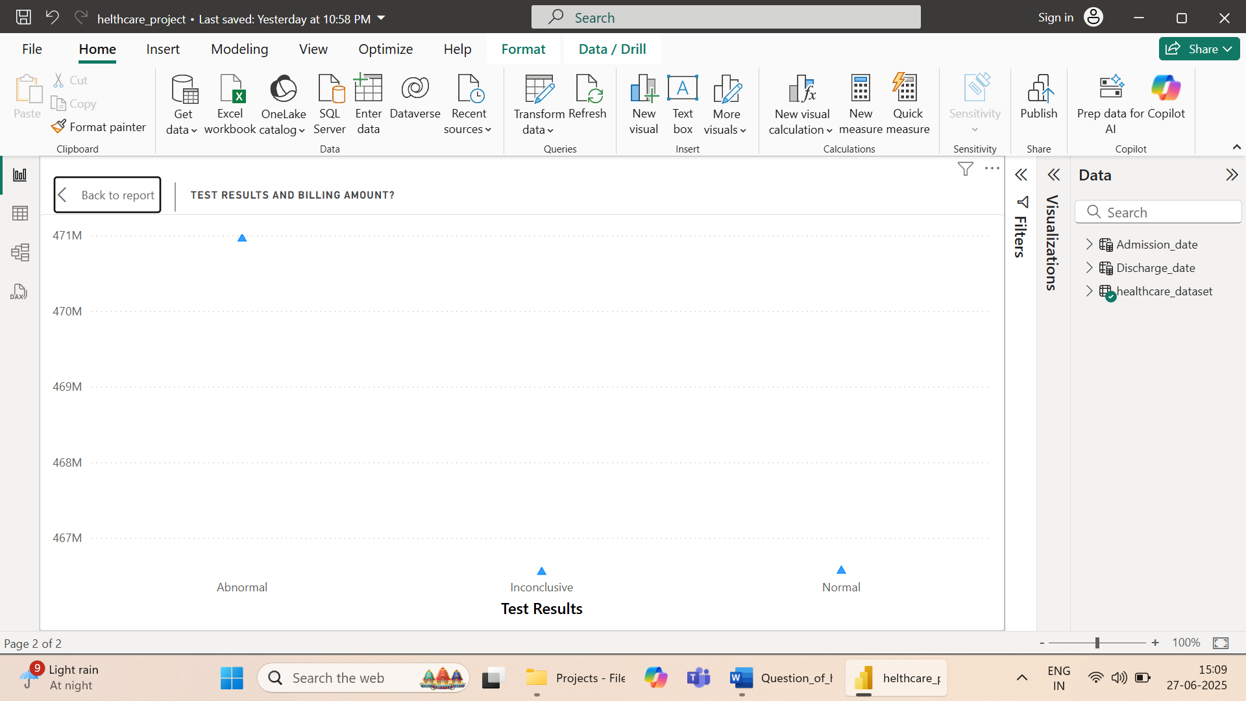

**📅 6. Discharge & Hospital Stay Patterns**

**Average Length of Stay**

* Average patient stay: 15.50 days.

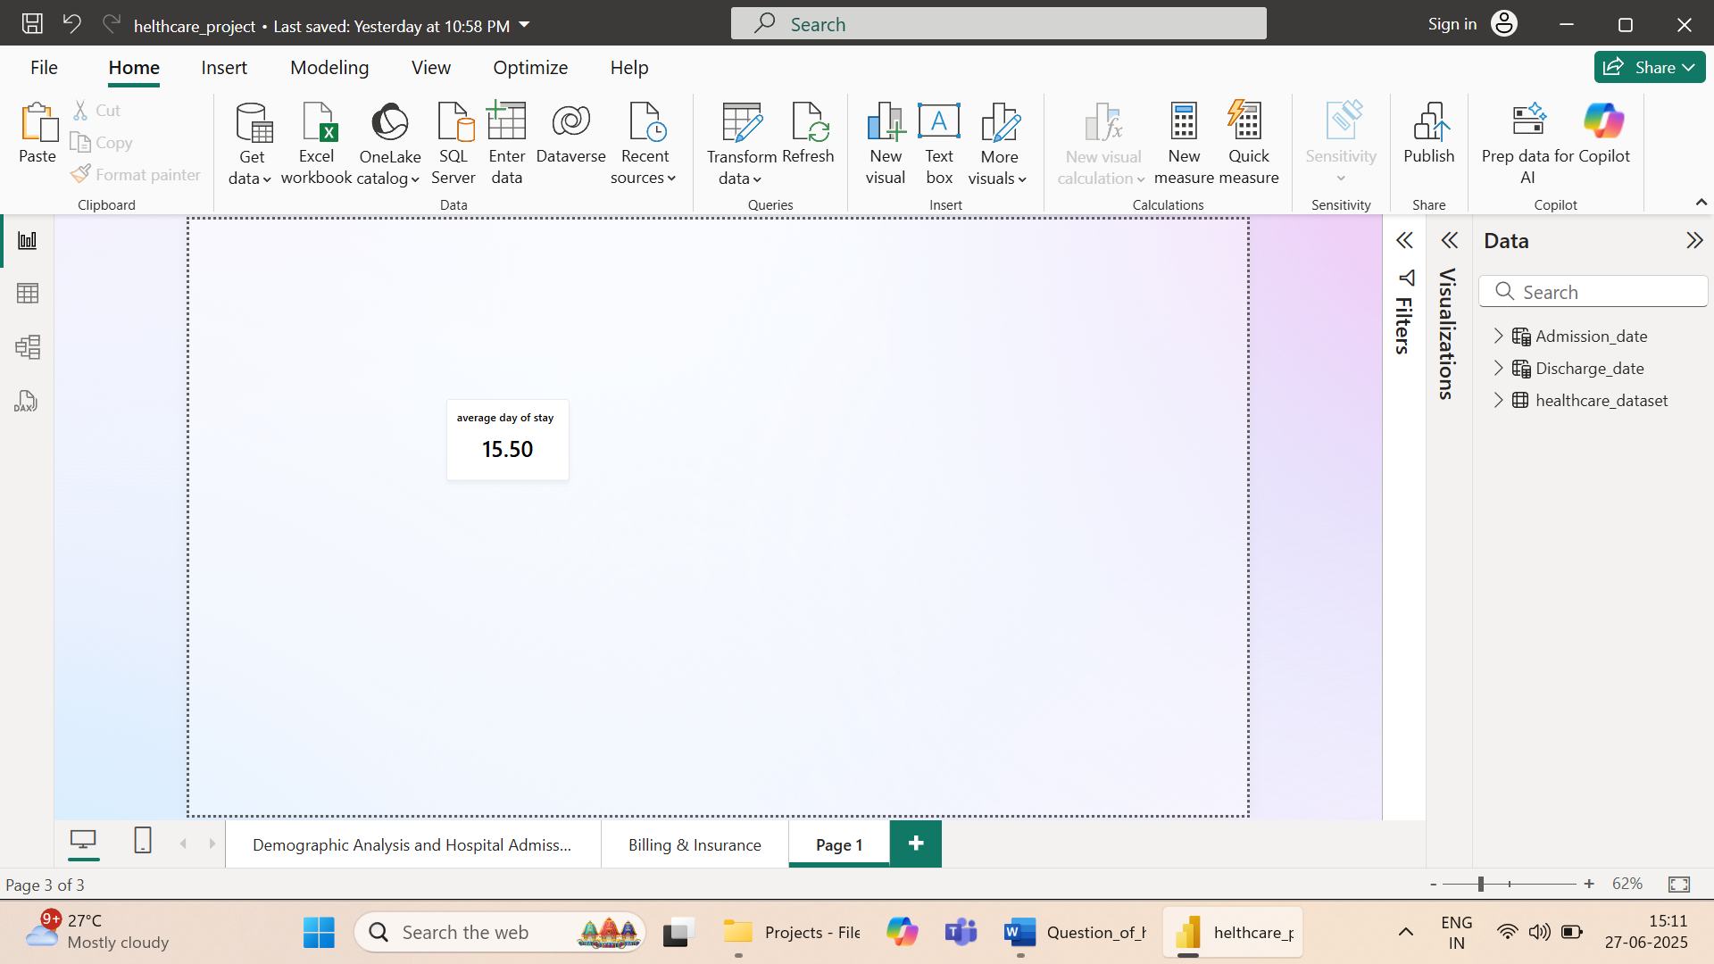

**Discharges by Weekday**

* Highest discharges: Weekday, lowest: weekend

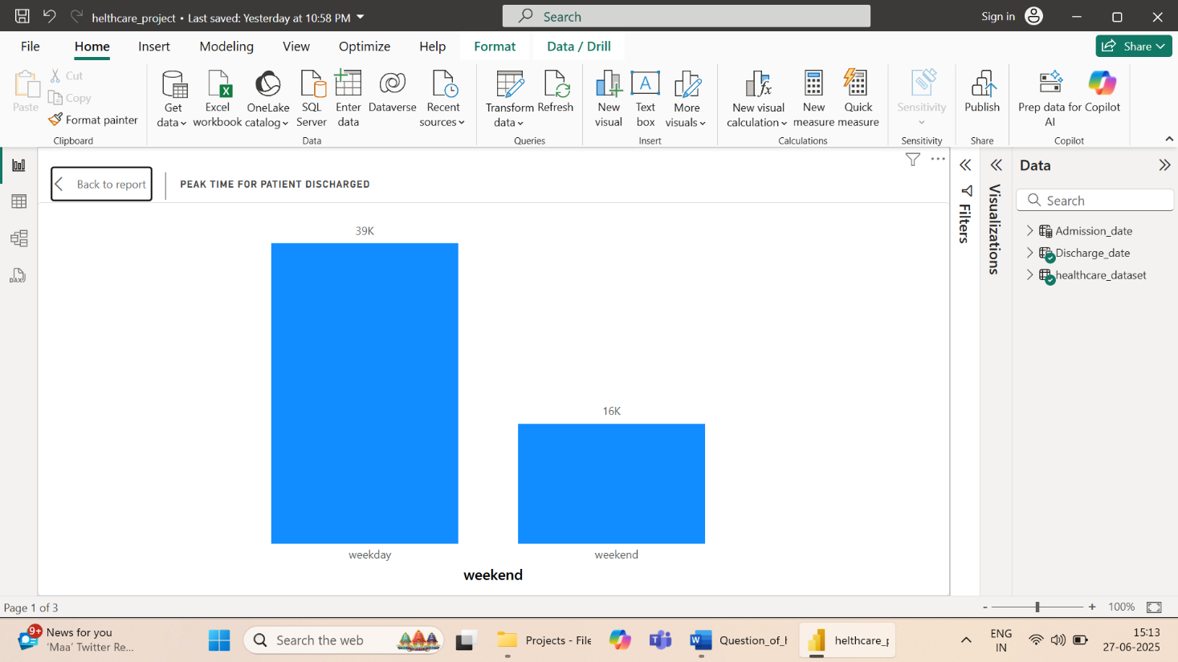

**📌 Conclusions & Recommendations**

* **Patient Demographics:** Focus on care planning for middle-aged patients (60-90), who make up the majority.
* **Billing Insight:** Room number 391and certain insurance providers lead to higher costs.
* **Gender of male and female equal**
* **Hospital Operations:** Resource allocation should consider admission peaks.

**📷 Appendix**

**Power BI Dashboards**

* Screenshot of dashboard overview

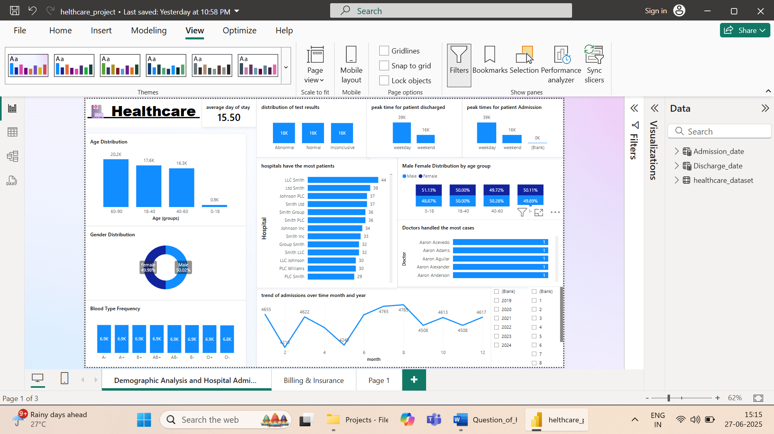

**DAX Measures Used (Examples)**

Created Admission date table by Admission date column

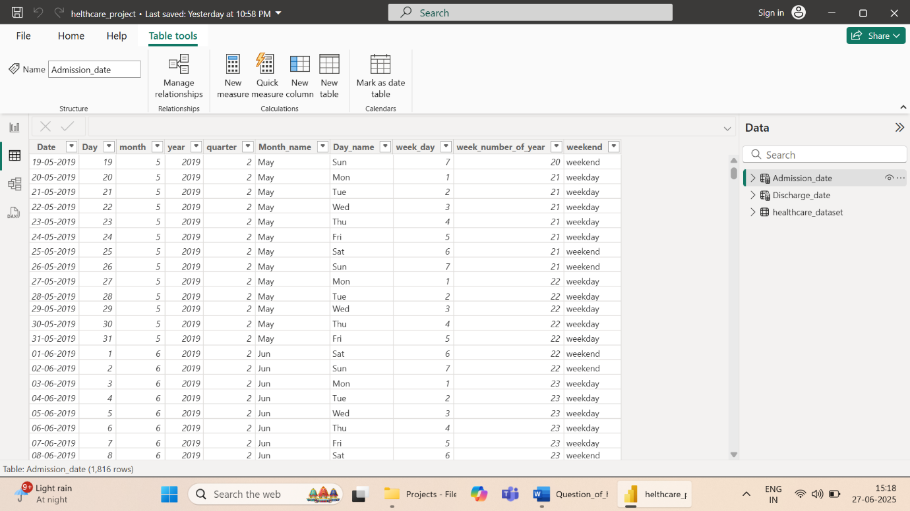

Created Discharged date table by Discharged date column

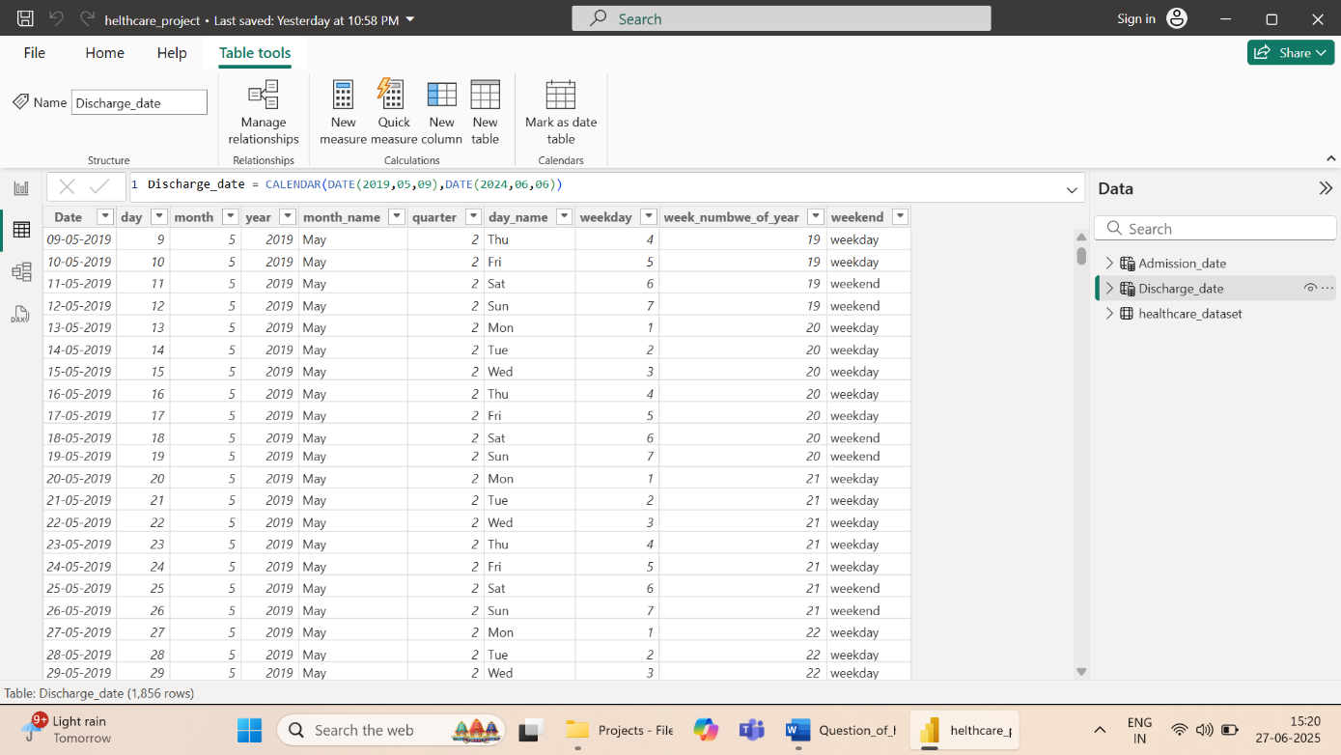

* Created Age Group by using Group function 0-18,18-40,40,60 and 60-90
* Created Measure for to find how may days patient stay
* LengthOfStay = DATEDIFF(healthcare_dataset[Date of Admission], healthcare_dataset[Discharge Date], DAY)
* Created group for length od stay using group function 1-10,11-20,21-30